Software Design, Prototype, and Quality Evaluation: StudyTrack Task Creation & Management Feature
Draven Chen
Southern New Hampshire University
Software Engineering
August 6, 2026

Feature Selection and Rationale
For this assignment I selected FR1, Task Creation and Management, and its corresponding backlog item US1 from Assignment 1: “As a student, I want to create a task with a due date and priority, so that I can keep track of upcoming assignments in one place.” I chose this feature because it is the foundation the rest of StudyTrack depends on. Study session scheduling, reminders, and the progress dashboard all read or reference Task records, so nothing else in the product backlog can be meaningfully implemented or tested until task creation and management exists and is reliable. It is also the feature every other user story assumes is already working, which made it the natural first vertical slice for Sprint 1 in the original sprint plan. Beyond its structural importance, task management is the single feature stakeholders described most consistently in early conversations as the reason they would use the tool at all, which made it the clearest candidate for a first working prototype and for a meaningful design and testing exercise.

Software Design Artifact
Two complementary artifacts model this feature: a component diagram showing the static structure and responsibilities, and a sequence diagram showing the dynamic flow of a single “create task” interaction. The component diagram splits the feature into four responsibilities: View (renders the form and task list and captures input, with no business logic), TaskController (validates input and enforces the rule that title and due date are required, with no DOM or storage access), TaskStore (the only module allowed to read or write localStorage), and the Task data shape itself. The sequence diagram traces a single createTask(input) call from the student through the View and TaskController down to TaskStore and localStorage, including the alternate path where validation fails and errors are returned to the View instead of a new record being created.

Design Artifacts
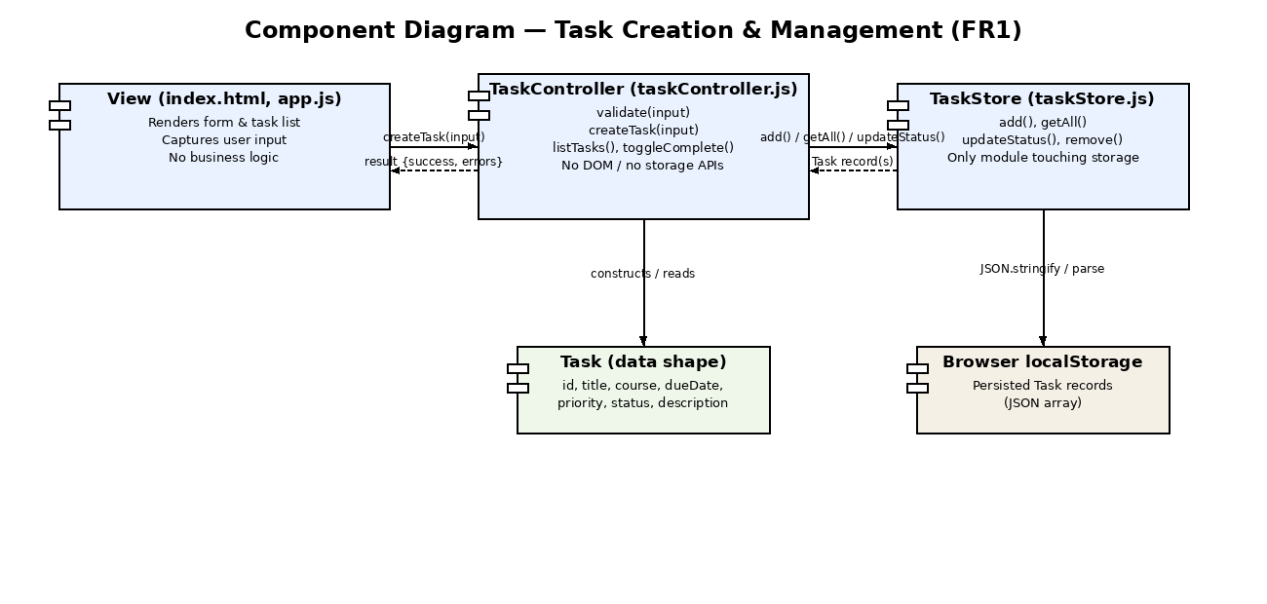
Figure 1. Component diagram showing the View, TaskController, TaskStore, and data responsibilities for the Task Creation & Management feature.
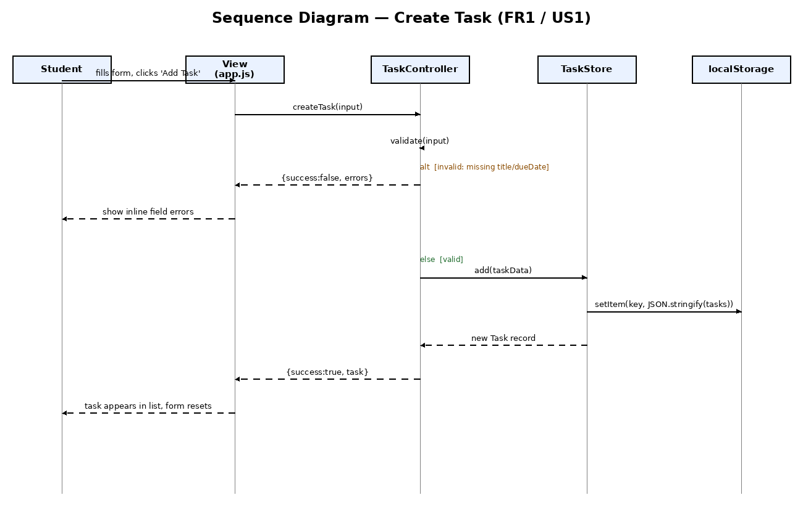
Figure 2. Sequence diagram for the Create Task flow, including the validation-failure alternate path.
This structure directly supports usability, reliability, and maintainability. For usability, isolating validation in TaskController means every invalid submission returns the same structured error object, so the View can consistently show inline, field-specific messages instead of a generic failure, reducing the guesswork a student faces when a submission is rejected. For reliability, funneling every read and write through TaskStore's add/getAll/updateStatus/remove functions means there is exactly one place where JSON parsing of stored data can fail, and exactly one place with defensive handling (the existing try/catch around JSON.parse), rather than that risk being duplicated across the codebase. For maintainability, the one-way dependency chain (View to TaskController to TaskStore) means the persistence mechanism could be replaced with a real backend API by rewriting TaskStore alone, and validation rules could change by editing TaskController alone, without either change touching the DOM-rendering code in app.js. Keeping the Task data shape as a plain object rather than embedding it in the UI layer also means the same shape can be reused by future features, such as study sessions and reminders, that reference a task.

Implementation
The prototype is a client-side web application (HTML, CSS, and vanilla JavaScript, no framework or backend) split into the four files the design specifies. It runs by opening index.html directly in a browser and persists task data through the browser's localStorage API. The screenshots below demonstrate task creation, validation, sorting by due date, marking a task complete, and filtering by course.
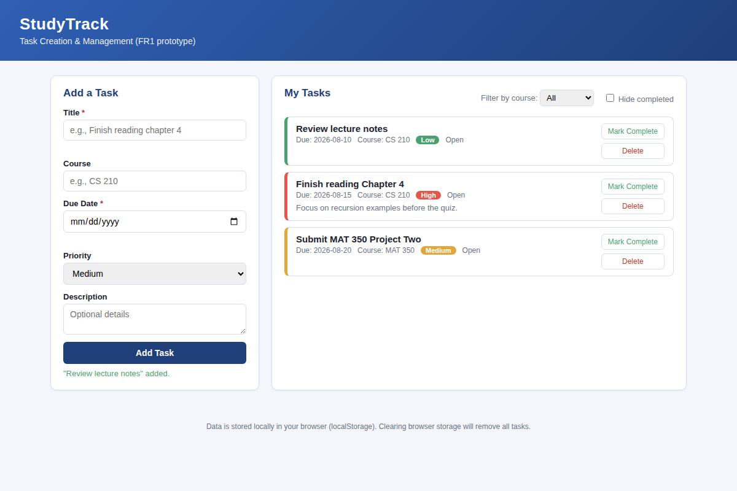
Figure 3. Three tasks created and automatically sorted by due date.
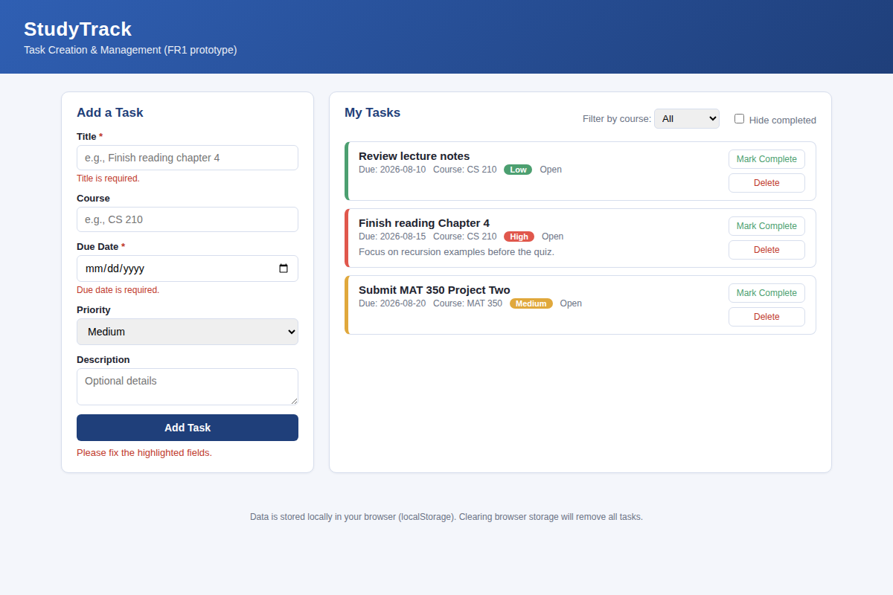
Figure 4. Inline validation errors when Title and Due Date are left blank.
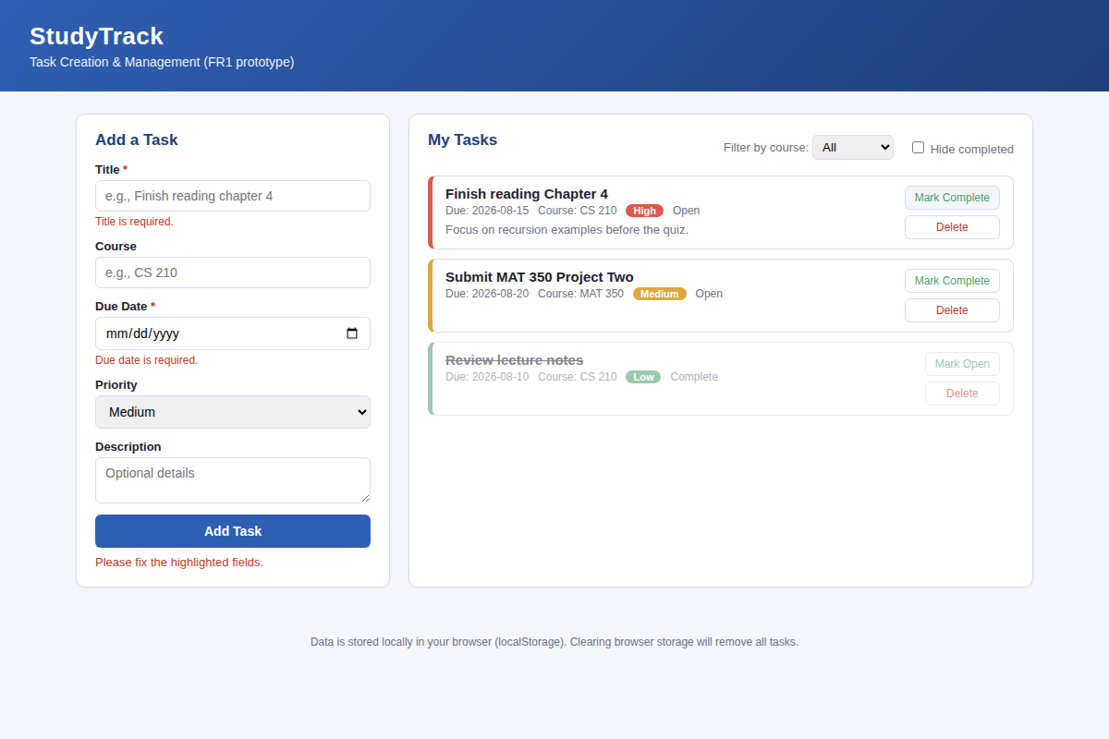
Figure 5. A completed task is struck through and sorted below open tasks.

Reflection: Design to Implementation
Moving from the diagrams to working code was mostly straightforward because the component boundaries had already been decided; writing taskController.js before app.js meant validation rules existed and were callable before any UI code depended on them. The main challenge was the sort-and-filter logic in listTasks(), which the design artifacts described only as a responsibility (“TaskController lists tasks”) without specifying the exact ordering rule, so I made an implementation-time decision (open tasks first, then ascending due date) that the sequence diagram never captured. A clear component boundary paid off during testing too: because TaskController never touches the DOM and TaskStore never touches validation, each layer's behavior could be tested independently of the browser UI. For future projects, I would add a short “behavior notes” entry during design for any responsibility with more than one reasonable implementation, such as sort order or how to handle a stale due date, so that ambiguity is resolved on paper rather than improvised during coding.

Testing and Quality Evaluation
The verification and validation plan below covers three functional-correctness cases (creating a valid task, rejecting an invalid one, and deleting a task) plus two quality-attribute cases: reliability of data persistence across a page reload, and a maintainability check confirming that only taskStore.js touches localStorage (verified by searching the source files directly). All five cases were executed against the running prototype using an automated Playwright script and passed.
ID | Test Case | Expected Result | Actual Result | Pass/Fail
TC1 | Create a task with only the required fields (title, due date) | Task is saved, appears in the list, defaults to Medium priority | 1 task created; default priority = Medium | Pass
TC2 | Submit the form with title and due date blank | Inline errors shown for both fields; no task added | Both error messages shown; task count unchanged | Pass
TC3 | Mark a task complete | Status changes to Complete; task sorts below open tasks | Task moved to bottom of list, marked Complete | Pass
TC4 (Reliability) | Reload the page after adding/completing tasks | All tasks and their statuses persist after reload | Task count and completed status unchanged after reload | Pass
TC5 | Delete a task | Task removed from list; its course removed from the filter if unused elsewhere | Task count decreased; course no longer in filter options | Pass

No functional defects were found during this round of testing; all five cases passed on the first execution. Testing did surface two quality issues that do not violate the current requirements but are worth flagging. First, the due-date field accepts any valid calendar date, including dates in the past, so a student can create a task that is already overdue at the moment of creation; this was not a stated requirement in Assignment 1, but it is a usability gap I would address by adding a non-blocking warning rather than a hard validation error, since a student may legitimately want to log a past-due item. Second, the delete action relies on the browser's native confirm() dialog, which works correctly but is difficult to style consistently and to test without special handling (the automated test script had to register a one-time dialog listener), which is a maintainability and testability concern; a future iteration should replace it with an in-page confirmation component consistent with the rest of the UI. Neither issue affects the reliability result in TC4, since both are edge cases in input handling rather than data-persistence defects, but both are recorded here so they can be prioritized in a later sprint.

